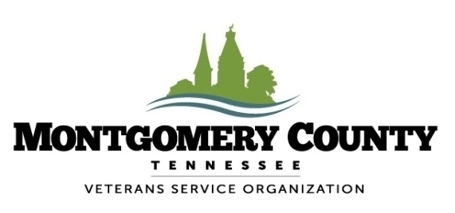
350 Pageant Lane, Suite 308 Clarksville, TN 37040
(931) 553-5173/5174 Fax: (931) 553-5176

2018 MONTGOMERY COUNTY VETERANS DAY PARADE

Date: Saturday, November 10, 2018
Time: 10:00 a.m.
Theme: Veterans Serving After Service
Entry Deadline: Friday, November 2, 2018

NOTE: Please return entries to the Veterans Service Organization in a timely manner, so that we may send your staging instructions and parade number. Please print legibly. If you would prefer an electronic version of this form, please email us at vetsvc@mcgtn.net. Any entries received after the deadline will not be considered.

Organization Name: __________________________________________________________________________
Address: _______________________________________________________________
City: _________________________________ State: __________________ Zip: _________________

Contact Person: ______________________________________________________________________________

(Print Name) ________________________________ (Signature) __________________________________

Phone: ________________________________ Email: _______________________________________________________

Description of entry: (Include, as close as possible, the number of people, vehicles by type, and names of key individuals participating.) ___________________________________________________________________________________
________________________________________________________________________________________________________________________________________________________________________________________________________________________
Additional information about your entry or organization that will help the media describe your participation in the parade. (Attach a separate sheet if necessary.) ________________________________________________________________ ________________________________________________________________________________________________________________________________________________________________________________________________________________________

NOTE: CANDY THROWING IS NOT ALLOWED BY MONTGOMERY COUNTY, AND THE VETERANS SERVICE ORGANIZATION WILL NOT BE RESPONSIBLE FOR ANY VIOLATIONS.

There will be a meeting on Nov 6th at 3:00 pm at the William O. Beach Civic Hall to discuss the staging area to MINIMIZE confusion and possible injuries to participants. Questions or concerns, email eanunez@mcgtn.net

(for office use only)
Date registration received ___________________
Parade Position Number __________

